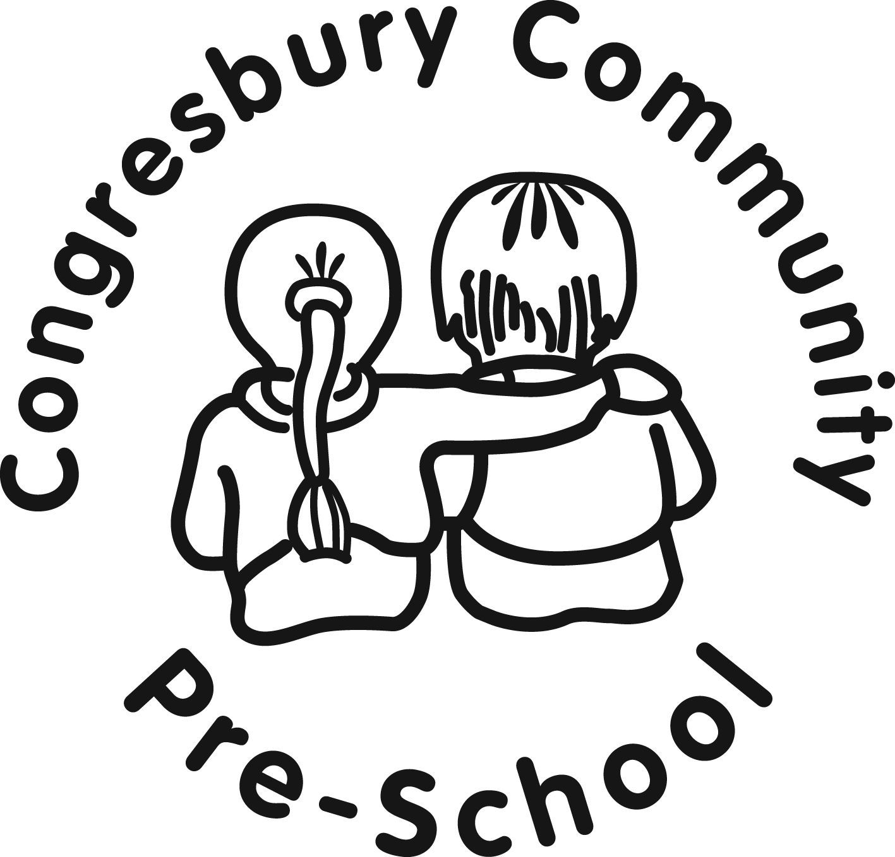

REGISTERED CHARITY NUMBER: 1015403
St Andrews School Site, Station Road, Congresbury, Bristol, BS49 5DX. Tel: 01934 707 262
http://www.congresburypreschool.org.uk email: congresburypreschool@aol.co.uk

Nappy changing
Policy statement
No child is excluded from participating in our setting who may, for any reason, not yet be toilet trained and who may still be wearing nappies or equivalent. We work with parents towards toilet training, unless there are medical or other developmental reasons why this may not be appropriate at the time.
We provide nappy changing facilities and exercise good hygiene practices in order to accommodate children who are not yet toilet trained.
We see toilet training as a self-care skill that children have the opportunity to learn with the full support and non-judgemental concern of adults.
Procedures
- All children are changed once during a session, or more frequently where necessary.
- We endeavour for key persons to change their key children, however, all staff are able to change all children.
- Children are changed within sight of other staff whilst maintaining their dignity and privacy at all times.
- Our changing area is warm, with a safe area to lay children.
- Each child provides their own nappies or pull ups and changing wipes.
- Our staff put on gloves and aprons before changing starts and the areas are prepared. Changing mats are cleaned with antiseptic spray after each use.
- All our staff are familiar with our hygiene procedures and carry these out when changing nappies Our staff never turn their back on a child or leave them unattended whilst they are on the changing mat.
- We are gentle when changing; we avoid pulling faces and making negative comments about ‘nappy contents’.
- We do not make inappropriate comments about children’s genitals when changing their nappies.
- In addition, we ensure that nappy changing is relaxed and a time to promote independence in young children.
- We encourage children to take an interest in using the toilet; they may just want to sit on it and talk.
- We encourage children to wash their hands using soap and water and have paper towels to hand.
- Older children access the toilet when they have the need to and are encouraged to be independent.
- We dispose of nappies and pull ups hygienically. Any soil (faeces) in nappies or pull ups is flushed down the toilet and the nappy or pull up is bagged and put in the bin. Cloth nappies, trainer pants and ordinary pants that have been wet or soiled are rinsed and bagged for parents to take home.
- We have a ‘duty of care’ towards children’s personal needs. If children are left in wet or soiled nappies/pull ups in the setting this may constitute neglect [and will be a disciplinary matter].

This policy was adopted by |  | (name of provider)
On |  | (date)
Date to be reviewed |  | (date)
Signed on behalf of the provider
Name of signatory
Role of signatory (e.g. chair, director or owner)

